# A general catch comparison method for multi-gear trials: application to a quad-rig trawl fishery for *Nephrops*

Browne, D1., Minto, C. 2, Cosgrove, R. 1, Burke, B. 2, McDonald, D. 1, Officer, R. 2, and Keatinge, M1.

1 Irish Sea Fisheries Board (BIM), New Dock Road, Galway, Ireland.

2 Galway Mayo Institute of Technology (GMIT), Dublin Road, Galway, Ireland.

## Abstract

Expeditious uptake of the quad-rig gear in the economically important Irish fishery for *Nephrops Norvegicus* made it difficult for developments in gear technology to keep pace. The main driver for increased use of the quad-rig trawl is increased catch rates of *Nephrops*. However, discarding of demersal species is likely to have negative impacts on the economics of the quad-rig trawl *Nephrops* fishery unless species and size-selectivity can be improved. The catch comparison method facilitates effective assessment of fishing gear modifications to reduce fisheries bycatch. Utilising a quad-rig trawl potentially increases the number of gears that can be included in a catch comparison study to four but current modeling methods which include error measurements are limited to two gears. Our study provides a robust statistical framework that incorporates the multivariate response, elucidates how covariates may influence performance of the gear, and facilitates discussion on gear specific management measures. We provide a new general multinomial modeling framework which enables fitting of multivariate normal random effects models in addition to a multivariate response. Modeling of catches from four quad-rig cod-ends with four different mesh sizes revealed significant effects of net position, total cod-end weight and carapace length on the numbers of Nephrops retained in each cod-end. Results suggest that management measures which specifically address the different catch profiles of different numbers of trawl-rigs used in *Nephrops* fisheries are required to optimise bycatch reduction in different fleet metiérs

*Keywords*

## Introduction

*Nephrops Norvegicus* is a commercially important species distributed throughout the North East Atlantic and Mediterranean Sea. Total landings of 66,500 tonnes in 2010 were predominantly attributed to the United Kingdom (58.1%) followed by Ireland (11.7%) and various other European Union (EU) countries operating in Atlantic and Mediterranean waters (FAO, 2010). More than 95% of EU *Nephrops* landings are taken using single or multi-rig trawlers which target *Nephrops* in mixed species fisheries (Ungfors *et al.*, 2013). The estimated value of Irish *Nephrops* landings at the first point of sale of in 2014 was €44.5M making it the most commercially important demersal species in that country (Cosgrove *et al.*, 2015). The use of four trawl multi-rigs (Figure 1) known as quad-rigs commenced in October 2012. By the end of 2014 quad-rigs accounted for ~ 80% of *Nephrops* landings by the Irish fleet (unpublished data, Marine Institute).

The main driver for increased uptake of the quad-rig is increased catch rates of *Nephrops* compared with the more traditional single or twin-rig trawl which are likely to result from a wider swept area of seabed without increasing the drag of the gear (Insert seafish ref). *Nephrops* catch weights were observed to increase by at least 50% in the North Sea and Celtic Sea in studies comparing quad with twin-rig trawls (BIM, 2014; Revill *et al.*, 2009). Such increases in catching efficiency may be beneficial in terms of improving operational performance but could lead to increases in the 15% discard rate of *Nephrops* below minimum landing or market size in Irish waters (MI, 2014). By-catch of undersized and non-targeted fish species is also a major issue in *Nephrops* trawl fisheries (e.g. Catchpole *et al.*, 2005; Catchpole and Revill, 2008; Nikolic *et al.*, 2015; Ungfors *et al.*, 2013). New requirements to restrict discarding of demersal species under Article 15 of EU regulation 1380/2013, the landing obligation, are likely to have negative impacts on the economics of *Nephrops* fisheries unless species and size-selectivity can be improved.

Gear modifications to reduce bycatch are generally assessed using either selectivity (e.g. McClanahan and Mangi, 2004; Millar, 1992; Millar and Fryer, 1999; Millar and Walsh, 1992) or catch comparison (e.g. Holst and Revill, 2009; Krag *et al.*, 2014; Sangster and Breen, 1998; van Marlen *et al.*, 2014). Practical advantages of the catch comparison method include commercial-like performance and handling of the gear. In addition, the ease with which results of catch comparison experiments can be reported and interpreted (Holst and Revill, 2009) is likely to be of particular assistance to the fishing industry in addressing challenges posed by regulation of their catch composition, for example the EU landing obligation. Whilst catch comparisons can only compare the gears included in particular experiments (Frandsen, 2010), utilising a quad-rig trawl increases the number of gears that can be included in the experiment to four. This potentially allows assessment of more concurrent experimental settings and providing substantially more information than twin or single-rig catch comparisons.

Development of a Generalized Linear Mixed Model (GLMM) approach to catch comparison provides a statistical and graphical comparison of fish catch at length by two fishing gears with associated error measurements, improving the power of catch comparison analyses (Holst and Revill, 2009). Binomial GLMMs are, however, limited to experiments with two response categories. Multinomial models can generalise logistic regression to multi-category response problems (McCullagh and Nelder, 1989), i.e. those with two or more fishing gears.

Here, we test the potential benefits of applying a multinomial modelling approach to a comparison of *Nephrops* catches in a quad-rig trawl with four simultaneously deployed test gears. Our goals are to provide a robust statistical framework that incorporates the multivariate response, elucidates how covariates may influence performance of the gear, and facilitates discussion on gear specific management measures.

## **Materials and Methods**

Addressing the particular requirements of catch comparison in quad-rig trials required a modified trial design and modelling framework.

### Trial design

Data were collected from a catch comparison experiment carried out in the western Irish Sea, ICES sub-area VIIa, between 18 -21 July 2015. The trial vessel fished a multi-rig trawl consisting of 4 identical nets each fitted with a diamond mesh cod-end with nominal mesh sizes of 70, 80, 90 or 100 mm (mesh size descriptors used henceforth). Cod-ends were constructed with single 6 mm, polyethylene twine, with mean omega mesh gauge measurements of 70.8, 80.8, 92.6 and 103.0 mm. Mesh size in the top and bottom panels behind the head-line and in the lower wing ends of the net was 80 mm, while mesh size in the upper wing ends was 160 mm. Corresponding to normal fishing practices in the area, square mesh panels of 120 mm mesh size were mounted 9 to 12 m from the cod-line. Here, ‘net’ describes the whole trawl body. Net positions were fixed and cod-end positions were rotated daily to account for potential differences in fishing power without confounding cod-end mesh and net position effects. Described as ‘net configuration’, each cod-end was deployed on each net for 3 hauls which equates to one out of four fishing days, with the data from 12 consecutive hauls analysed. Operations approximating normal commercial fishing practice were carried out with haul duration, towing speed and depth of ground fished averaging: 04:47 h, 3.1 knots and 48 m respectively. Further information on the vessel and gear used in the trial is presented in Table 1. Catches of fish and *Nephrops* were weighed and random representative subsamples were selected. *Nephrops* carapace length was recorded to the nearest mm below using digital callipers connected to a wireless recording system (Cosgrove *et al.*, 2015).

### Model development

In a quad-rig trial the response was a matrix of *Nephrops* counts per observation () and cod-end (). Each row contained four counts (one for each cod-end) for length-bin in haul . For example, for the 30mm length bin in haul 5, the response might be denoting that 10 *Nephrops* were counted in the first cod-end, 20 in the second, etc.

The response data are multivariate counts for which interest lies in describing how the relative proportions retained per length-class in each of the cod-ends varies as a function of the cod-end design (predominantly mesh size) and other explanatory variables. When trials consist of counts per category (cod-end), a starting distribution is the multinomial (Agretsi, 2002) with probability mass function

(1)

where: is the count in the th cod-end and ; and is the probability of outcome , , implying 3 parameters in the basic model.

#### Covariates

A common model when explanatory variables are included (such as carapace length) is the multinomial logit model, where the probability of a given outcome depends on values of the explanatory variables for the th observation (row):

, (2)

where is a () row vector of case/row-specific explanatory variables for the th observation and is a () column vector of parameters for the th category. Note that so that the first cod-end is set to the baseline, assuring that the probabilities sum to unity across the categories (Greene, 2000). The explanatory variables included were: carapace length, net configuration (the cod-end positions were changed each night to account for position effects thus 4 net configurations were tested) and total weight per cod-end. The total weight per cod-end covariate deserves special attention as it requires different treatment to the case-specific variables such as carapace length. Cod-end bulk weights vary by cod-end and can thus be considered a choice-specific attributes. Choice-specific variables in a multinomial setting are typically modelled as conditional logit models (McFadden, 1973), which remove the subscript *k* from the parameter for that covariate, thus for weight the effect is so at equal weights in the cod-end the effect is cancelled. We thus use a mixture of case-specific and choice-specific covariates leading to the fixed effects model

(3)

#### Subsampling offset

As the counts are sub-sampled, it is also necessary to include an offset for the proportion of the catch in each cod-end sampled (Holst and Revill, 2009). In a twin-rig (two category) trial the offset is given by where and are the proportions of the catch sampled in the test and control, respectively (Holst and Revill, 2009). In the quad-rig trial with the proportion of the th net in the th observation sampled, the vector of offsets for the is given by , where the first zero comes from . A numerical illustration of the offset terms is provided in the Appendix. The offset is incorporated as

, (4)

*Multinomial random effects*

Counts for category in a multinomial have an expected mean and variance , however, there is often more variability in the counts than the mean-variance (and covariance) allows for, which is termed overdispersion (Hinde and Demétrio, 1998). This may reflect uncaptured variability or clustering, in particular haul-level variability not accounted for when the observations are treated as independent multinomials. Overdispersion was tested for in the best fitting multinomial model by testing the residual deviance on a chi-squared distribution with the residual degrees of freedom (Paul et al. 1989).

Given that the observations are clustered by hauls, the approach we focus on for accounting for extra-multinomial variability is to include random effects in the model (Hinde and Demétrio, 1998). Multinomial random effects include the baseline category logit random effects model (Hartzel et al., 2001). This model has a multinomial response distribution with the addition of random effects that more explicitly capture the variability attributable to hauls, as opposed to the more general additional variability unattributed to specific grouping but included in, for example, the Dirichlet-multinomial model. The random effects multinomial model we test is an extension of Equation (4) given by

, (7)

where the random effects per haul have a multivariate normal distribution . The baseline category random effect is again set to zero, resulting in a trivariate normal distribution for . An arbitrary (6 parameter) covariance matrix structure, as recommended in Hartzel et al. (2001) was implemented.

#### Inference

We use likelihood ratio tests of nested models to test the significance of each of the fixed effects. As the models are estimated via maximum likelihood we also report Akaike’s Information Criterion for each model. Overall predictions in the presence of a categorical variable (net configuration) were obtained by setting the net configuration values in the predicted model matrix to 1/3 (Fox, 2003).

#### Estimation

Estimation of the multinomial random effects model necessitates integrating over the random effects to estimate the marginal likelihood. We did not find readily available software to fit Equation (7) we therefore wrote an estimation routines in AD Model Builder (ADMB) (Fournier et al., 2012). The ADMB-RE module (Skaug and Fournier, 2006) was used to estimate the multinomial mixed conditional and logit random effects model with the variance-covariance matrix specified via a Cholesky-decomposition. ADMB also allows for estimates of uncertainty on the linear predictor scale via the delta-method approximation. All pre- and post-processing code was run in R 3.2.0 (R Core Team, 2015). ADMB code for running the multinomial random effects model is stored at (http://www.github.com/mintoc/epif/multinomial).

## Results

A total of 15,443 *Nephrops* were measured during the 12 hauls of the trial. Most of the carapace length measurements were in the range of 20-45mm (Figure 2). Considerable between-haul variability was observed in the proportions retained at length with some hauls displaying consistently lower or higher retention across carapace lengths (Figure 2). The observed proportions at the extremes of the length distribution were more variable but derived from fewer observations (e.g., zero or unity proportions in Figure 2).

Separate inclusion of each of the main effects (carapace length, net configuration and bulk weight) resulted in large decreases in the AIC relative to a model with fixed proportions (Table 2). Net configuration was important with inner port position typically fishing worst, and the outer starboard or port fishing better. These likely reflect differences in fishing power of the nets. Higher-order carapace length effects (allowing more curvature in the proportions over length) did not improve the AIC (Table 2). Combining carapace length and total cod-end weight or net configuration resulted in further decreases in the AIC and the model including the three main effects fit best overall (Table 2). ). Note that higher-order interactions of the explanatory variables were not included in the models, as with 12 hauls and 4 test gears there are 36 independent cells from which to estimate the parameters and the models can quickly become overfit.

From the best fitting model the estimated covariance and correlation matrices of the random effects were:

and , respectively.

Note that the variance of the random effects was similar across the three log-odds ratios (diagonal of ) and strong correlation exists between the random effects (Figure 3). The magnitude of the variance of the random effects (e.g., ) implies that having accounted for the fixed effects of carapace length, net configuration and total cod-end weight (Table 2), the expected proportions vary in extremes by +/- 12% by haul (inverse logit of 95% intervals -0.5, +0.5). Typically the variability will be lower than this (Figure 3). The relatively low inter-haul variability estimated together with the model comparisons (Table 2) highlight that a considerable amount of between-haul variability is captured by the fixed effects of net configuration and bulk weight though some inter-haul variability remains, as captured by the random effects (Figures 3 and 4).

The by-haul predictions fit the data well in both the fixed effects and random effects models (Figure 4), though the random effects models expectedly fit some haul and mesh combinations better (e.g., 70mm and 80mm in hauls 3 and 5). Overall predictions show a higher proportion of small *Nephrops* retained in the 70mm, the proportion of smaller *Nephrops* decreases as cod-end mesh size increases (Figure 5). In addition, the slope of the proportion retained over length classes goes from negative in the 70mm and 80mm to positive in the 90mm and 100mm (Figure 5). A higher proportion of larger *Nephrops* were retained in the 90mm and 100mm cod-ends (Figure 5).

The estimated confidence intervals on the mean proportions are narrow reflecting the number of observations contributing to the mean with the considerable between-haul variability accounted for via the fixed and random effects (Figure 4). Note that confidence intervals on proportions cannot be interpreted separately as the proportions necessarily sum to one.

## Discussion

Our study developed a multinomial random effects model that included: case-specific and choice-specific covariates, cod-end specific sub-sampling, and multivariate random haul effects. The method is generally applicable to multi-gear catch-comparison studies, as demonstrated in our analyses of a quad-rig trawl *Nephrops* fishery. Here we discuss the model developments, main findings of the quad-rig application and fishery implications.

Model developments

Examples of the application of multinomial models to fisheries include analysis of egg stages (Ibaibarriaga *et al.*, 2007; Stratoudakis *et al.*, 2006), comparisons of age-length keys (Gerritsen *et al.*, 2006), fleet behaviour (Ward and Sutinen, 1994) and discard survivability (Benoit *et al.*, 2010). We extended the traditional multinomial logit model to include the specific requirements of a catch-comparison trial such as choice-specific covariates (e.g., cod-end total catch weight) and haul-level random effects (to account for over-dispersion). The method is applicable to other catch comparison situations where multiple gears are tested concurrently. By incorporating these effects we have developed a general multinomial modelling framework with applications beyond the field of fisheries science. Hartzel et al. (2001), conceptually develop the baseline logit multinomial random effects model but, to our knowledge, no readily available open source code exists for fitting this model. The use of ADMB-RE enables fitting of multivariate normal random effects models in addition to a multivariate response.

Using a Dirichlet-multinomial distribution offers an alternative method for modelling count data with a response with two or more categories. The Dirichlet-multinomial model is a multivariate extension of the beta-binomial distribution and is used in cases where data exhibits variance greater than expected in a multinomial, referred to as over dispersion. Over dispersion in the Dirichlet-multinomial is accounted for by an additional set of parameters per response level, allowing for an additional variability in the response counts (Thorsén, 2014). We chose to develop the multinomial random effects model over applying the Dirichlet-multinomial model, as the over-dispersion is likely at the haul-level more than the individual observation level. A combined Dirichlet-multinomial random effects model could be developed in future.

Covariate effects

Net position, total cod-end weight and carapace length significantly affected the numbers of *Nephrops* retained in the different cod-end mesh sizes (Table 2). Similar to a previous study conducted in the Irish Sea (Briggs *et al.*, 1999) and a study in the Bay of Biscay (Nikolic *et al.*, 2015), proportionally less smaller *Nephrops* were retained as mesh size increased (Figures 3 & 4). This can be explained by the fact that larger mesh opening angles are known to influence *Nephrops* selectivity (Frandsen *et al.*, 2010).

Total catch weight is known to affect mesh openings and cod-end size selection for a range of fish species (Campos *et al.*, 2003; Herrmann and O’Neill, 2005) and the crustacean Aristeus antennatus (Campos *et al.*, 2003). The significant effect of total catch weight on the proportion of *Nephrops* caught in the current study confirms the influence of this parameter on an additional crustacean species (*Nephrops norvegicus*).

Net position was an important variable explaining a considerable amount of inter-haul variability (Table 2). Non-rotation of the gears could result in confounding mesh effects with position effects. Position effects may result from differences in fishing power of the nets and asymmetry of: doors, sweeps, net geometry, warp length, and washing effects. We found that the simplest way to mitigate for these effects is to rotate the gears so that each gear has multiple opportunities to fish in each position. Logistical constraints limit the number of rotations but we found a rotation each night to be a feasible compromise between logistics and position mitigation. Further assessment of position effects on quad-rigs using net sensors (Sangster and Breen, 1998) or towed sonar could further assist in reducing associated variability and lead to improvements in operational efficiency.

The model allows for additional covariates to be included. Variables we did not incorporate in the model include: haul duration, wing-end spread, depth, time of day, tidal effects and weather, among others. The effects of these variables will be captured to some extent by the random effects estimated in the model (Figure 4). They could also be included as fixed effects but the number of covariates that can be included is limited by the number of tows and meshes in the trial (i.e., available degrees of freedom).

Fishery implications

The finding that total cod-end catch weight influences the proportion of *Nephrops* retained has important implications for the development of gear specific management measures in relation to multi-rig trawls. Thought to be associated with lower headline height and altered sweep arrangements, reductions in total catches of up to 61% of cod, 38% of haddock, and 59% of whiting were observed in trials which compared catches in quad and twin-rig trawls in the Celtic and North Seas (BIM, 2014; Revill *et al.*, 2009). Furthermore, significantly increased proportions of small *Nephrops* and cod were retained in the quad-rig compared with the twin-rig in the Celtic Sea study (BIM, 2014). Results of the current and latter studies suggest that lower total catch weights associated with reduced fish catches in quad-rig trawls are likely to reduce cod-end selectivity compared with single or twin-rig trawls. Hence, management measures which specifically address the different catch profiles of different numbers of trawl-rigs used in *Nephrops* fisheries are required to optimise bycatch reduction and quota utilisation under the EU landing obligation.

In terms of the practicalities of introducing new measures, an increase in minimum mesh size would be the simplest and easiest to implement in terms of cost and practical considerations. Although different diamond cod-end mesh sizes do not generally affect the selection range, they do affect the quantities of *Nephrops* retained (Catchpole and Revill, 2008). Our finding that larger cod-end mesh sizes retained significantly lower proportions of small *Nephrops* (Figures 3 and 4) bodes well for the development of a management measure in relation to increased minimum cod-end mesh size. The reasons why higher proportions of larger *Nephrops* were retained in the larger cod-end mesh sizes of the quad-rig (Figures 3 & 4) are unknown but may, if confirmed, be an additional potential benefit of increase mesh size in the quad-rig trawl fishery for *Nephrops*. The current minimum cod-end mesh size in Irish waters is 70 mm. In the context of the landing obligation, economic modelling of an increase in minimum cod-end mesh size demonstrated that reduced catches of small *Nephrops* in an 80 mm cod-end can provide more opportunity to catch increased quantities of larger more valuable *Nephrops,* leading to marginal increases in vessel profitability over the course of a fishing season (Cosgrove *et al.*, 2015). Results of the current study suggest that a larger increase in minimum cod-end mesh size would be required in quad-rig trawls to optimise bycatch reduction in that métier compared with twin or single-rig trawls.

Acknowledgements

We are grateful to the owner Ivan Wilde and crew of MFV Our Lass II for their participation during the cod-end mesh size gear trial. Richard Curtin, BIM for estimating the total value of Irish *Nephrops* landings and to Colm Lordan from the Marine Institute for information on Quad-rig activity in Irish waters. This work was funded by the Irish Government and part financed by the EC under the Irish National Development Plan 2007 – 2013 through the BIM Marine Environment Protection Measure.

References

Benoit, H. P., Hurlbut, T., and Chasse, J. 2010. Assessing the factors influencing discard mortality of demersal fishes using a semi-quantitative indicator of survival potential. Fisheries research, 106: 436-447.

BIM. 2014. Catch comparison of Quad and Twin-rig trawls in the Celtic Sea Nephrops fishery, BIM Gear Technology Report. 4 pp.

Briggs, R., Armstrong, M., and Rihan, D. 1999. The consequences of an increase in mesh size in the Irish Sea *Nephrops* fishery: an experimental approach. Fisheries research, 40: 43-53.

Campos, A., Fonseca, P., and Erzini, K. 2003. Size selectivity of diamond and square mesh cod ends for four by-catch species in the crustacean fishery off the Portuguese south coast. Fisheries research, 60: 79-97.

Catchpole, T., Frid, C., and Gray, T. 2005. Discards in North Sea fisheries: causes, consequences and solutions. Marine Policy, 29: 421-430.

Catchpole, T., and Revill, A. 2008. Gear technology in Nephrops trawl fisheries. Reviews in Fish Biology and Fisheries, 18: 17-31.

Cosgrove, R., Browne, D., McDonald, D., Curtin, R., and Keatinge, M., 2015. Assessment of an increase in cod-end mesh size in the Irish Sea *Nephrops* fishery. Irish Sea Fisheries Board (BIM), Marine Technial report, 16 pp.

FAO 2010. Landing data for Nephrops norvegicus in 1955–2010 using FAO programme and database FishStatJ. <http://www.fao.org/fishery/statistics/software/fishstatj/en>.

Frandsen, R. P., 2010. Reduction of discards in the Danish Nephrops (*Nephrops norvegicus*) directed trawl fisheries in Kattegat and Skagerrak. Aalborg University, The Faculty of Engineering and Science, Department of Biotechnology, Chemistry and Environmental Engineering. Ph.D., 135 pp.

Frandsen, R. P., Herrmann, B., and Madsen, N. 2010. A simulation-based attempt to quantify the morphological component of size selection of *Nephrops norvegicus* in trawl codends. Fisheries research, 101: 156-167.

Gerritsen, H. D., McGrath, D., and Lordan, C. 2006. A simple method for comparing age–length keys reveals significant regional differences within a single stock of haddock (Melanogrammus aeglefinus). ICES Journal of Marine Science: Journal du Conseil, 63: 1096-1100.

Herrmann, B., and O’Neill, F. G. 2005. Theoretical study of the between-haul variation of haddock selectivity in a diamond mesh cod-end. Fisheries research, 74: 243-252.

Holst, R., and Revill, A. 2009. A simple statistical method for catch comparison studies. Fisheries research, 95: 254-259.

Ibaibarriaga, L., Bernal, M., Motos, L., Uriarte, A., Borchers, D. L., Lonergan, M. E., and Wood, S. N. 2007. Characterization of stage-classified biological processes using multinomial models: a case study of anchovy (Engraulis encrasicolus) eggs in the Bay of Biscay. Canadian Journal of Fisheries and Aquatic Sciences, 64: 539-553.

Krag, L. A., Herrmann, B., and Karlsen, J. D. 2014. Inferring fish escape behaviour in trawls based on catch comparison data: Model development and evaluation based on data from Skagerrak, Denmark. Plos One, 9: e88819.

McClanahan, T. R., and Mangi, S. C. 2004. Gear-based management of a tropical artisanal fishery based on species selectivity and capture size. Fisheries Management and Ecology, 11: 51-60.

McCullagh, P., and Nelder, J. A. 1989. Generalized Linear Models. 2nd edition*,* Chapman and Hall, London, UK. 512 pp.

MI. 2014. The Stock Book 2014 : Annual Review of Fish Stocks in 2014 with Management Advice for 2015. Galway, Ireland, 624 pp.

Millar, R. B. 1992. Estimating the size-selectivity of fishing gear by conditioning on the total catch. Journal of the American Statistical Association, 87: 962-968.

Millar, R. B., and Fryer, R. J. 1999. Estimating the size-selection curves of towed gears, traps, nets and hooks. Reviews in Fish Biology and Fisheries, 9: 89-116.

Millar, R. B., and Walsh, S. J. 1992. Analysis of trawl selectivity studies with an application to trouser trawls. Fisheries research, 13: 205-220.

Nikolic, N., Diméet, J., Fifas, S., Salaün, M., Ravard, D., Fauconnet, L., and Rochet, M.-J. 2015. Efficacy of selective devices in reducing discards in the *Nephrops* trawl fishery in the Bay of Biscay. ICES Journal of Marine Science.

Revill, A., Course, G., and Pasco, G., 2009. More prawns and fewer cod caught in trials with multi-rig prawn trawl, CEFAS. 3 pp.

Sangster, G. I., and Breen, M. 1998. Gear performance and catch comparison trials between a single trawl and a twin rigged gear. Fisheries research, 36: 15-26.

Stratoudakis, Y., Bernal, M., Ganias, K., and Uriarte, A. 2006. The daily egg production method: recent advances, current applications and future challenges. Fish and Fisheries, 7: 35-57.

Ungfors, A., Bell, E., Johnson, M. L., Cowing, D., Dobson, N. C., Bublitz, R., and Sandell, J. 2013. Chapter Seven - Nephrops Fisheries in European Waters. *In* Advances in Marine Biology, pp. 247-314. Ed. by L. J. Magnus, and P. J. Mark. Academic Press.

van Marlen, B., Wiegerinck, J. A. M., van Os-Koomen, E., and van Barneveld, E. 2014. Catch comparison of flatfish pulse trawls and a tickler chain beam trawl. Fisheries research, 151: 57-69.

Ward, J. M., and Sutinen, J. G. 1994. Vessel entry-exit behaviour in the gulf of Mexico shrimp fishery. American Journal of Agricultural Economics, 76: 916-923.

## Modelling references – to be included above (Brian, please!)

Agresti, A. (2002). *Categorical Data Analysis* (2nd edition). John Wiley & Sons, Inc., Hoboken, New Jersey.

Chen, J., & Li, H. (2013). Variable selection for sparse dirichlet-multinomial regression with an application to microbiome data analysis. *The Annals of Applied Statistics*, 7(1) 1-25.

Fournier, D.A., H.J. Skaug, J. Ancheta, J. Ianelli, A. Magnusson, M.N. Maunder, A. Nielsen, and J. Sibert. (2012). AD Model Builder: using automatic differentiation for statistical inference of highly parameterized complex nonlinear models. *Optimization Methods Software*. 27:233-249.

Fox, J. (2003). Effect Displays in R for Generalised Linear Models. Journal of Statistical Software, 8(15), 1-27.

Greene, W.H. (2000). *Econometric Analysis* (4th edition). Prentice Hall, Upper Saddle River, New Jersey.

Hartzel, J., Agresti A., and Caffo, B. (2001). Multinomial logit random effects models. *Statistical Modelling*, 1, 81-102.

Hinde, J. and Demétrio, C.G.B (1998). Overdispersion: models and estimation. *Computational Statistics & Data Analysis* 27(2) : 151-170.

Holst, R. and Revill, A. (2009). A simple statistical method for catch comparison studies. *Fisheries Research* 95(2): 254-259.

McFadden, D. (1973). Conditional logit analysis of qualitative choice behavior. In P. Zarembka, ed., *Frontiers in Econometrics*. New York: Academic Press.

Miller, T.J. (2013). A comparison of hierarchical models for relative catch efficiency based on paired-gear data for US Northwest Atlantic fish stocks. *Canadian Journal of Fisheries and Aquatic Sciences*, 70: 1306-1316.

Paul, S.R., Liang, K.Y. and Self, S.G. (1989). On testing departure from the binomial and multinomial assumptions. *Biometrics*, 45: 231-236.

Plummer, M. (2003). JAGS: A Program for Analysis of Bayesian Graphical Models Using Gibbs Sampling. Proceedings of the 3rd International Workshop on Distributed Statistical Computing (DSC 2003), March 20–22, Vienna, Austria. ISSN 1609-395X.

R Core Team (2015). R: A language and environment for statistical computing. R Foundation for Statistical Computing, Vienna, Austria. URL <http://www.R-project.org/>

Skaug, H.J. and Fournier, D.A. (2006). Automatic approximation of the marginal likelihood in non-Gaussian hierarchical models. Computational Statistics & Data Analysis, 51(2): 699–709.

Table 1. Vessel and gear information

|  |  |
| --- | --- |
| Vessel | Our Lass II (DA261) |
| Vessel Length Overall (m) | 21.7 |
| Engine power (kW) | 484 |
| Home port | Howth, Ireland |
| Trawl type | Quad-rig for *Nephrops* |
| Trawl manufacturer | Pepe Trawls Ltd., Ireland |
| Otter board manufacturer/ type | Dunbar 7’6” |
| Fishing circle (m) | 380 x 80 |
| Door weight (kg) | 492 |
| Clump weight type/ weight (kg) | Roller/ 680 |
| Average door to clump spread (m) | 34.4 |
| Sweep length (m) | 50 + 20 |

Table 2. Multi-rig catch comparison. Multinomial random effects model fit summary. Explanatory variables are abbreviated: carapace length (CL), net configuration (NC) and cod-end total weight (W). The model degrees of freedom (df) includes 6 parameters parameterising the trivariate covariance matrix of the random effects.

|  |  |  |  |
| --- | --- | --- | --- |
| Explanatory variables | Log-likelihood | Model df | AIC |
| None | -2084.79 | 9 | 4187.58 |
| CL | -2062.56 | 12 | 4149.12 |
| NC | -2049.41 | 18 | 4134.82 |
| W | -2058.52 | 10 | 4137.04 |
| CL + NC | -2027.31 | 21 | 4096.62 |
| CL + W | -2036.2 | 13 | 4098.4 |
| NC + W | -2039.81 | 19 | 4117.62 |
| CL + NC + W | -2017.17 | 22 | 4078.34 |
| CL + CL2 + NC + W | -2016.79 | 25 | 4083.58 |

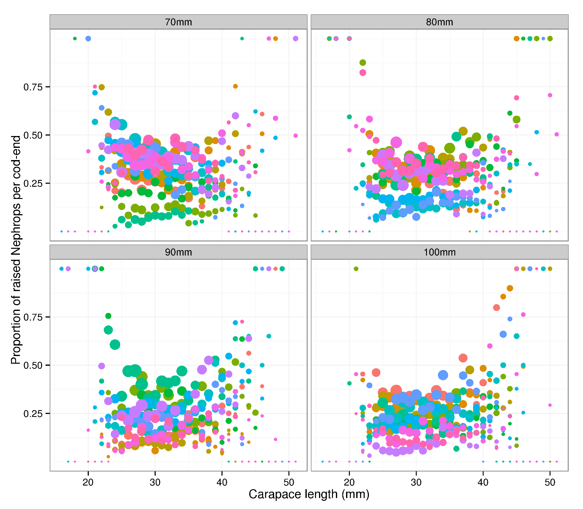

Figure 1. Multi-rig catch-comparison. Proportion of Nephrops retained per length-class by diamond mesh size. Hauls are coloured to demonstrate the haul effects. The diameter of the points is proportional to the log base 10 of the raised counts to illustrate where the distribution of the counts.

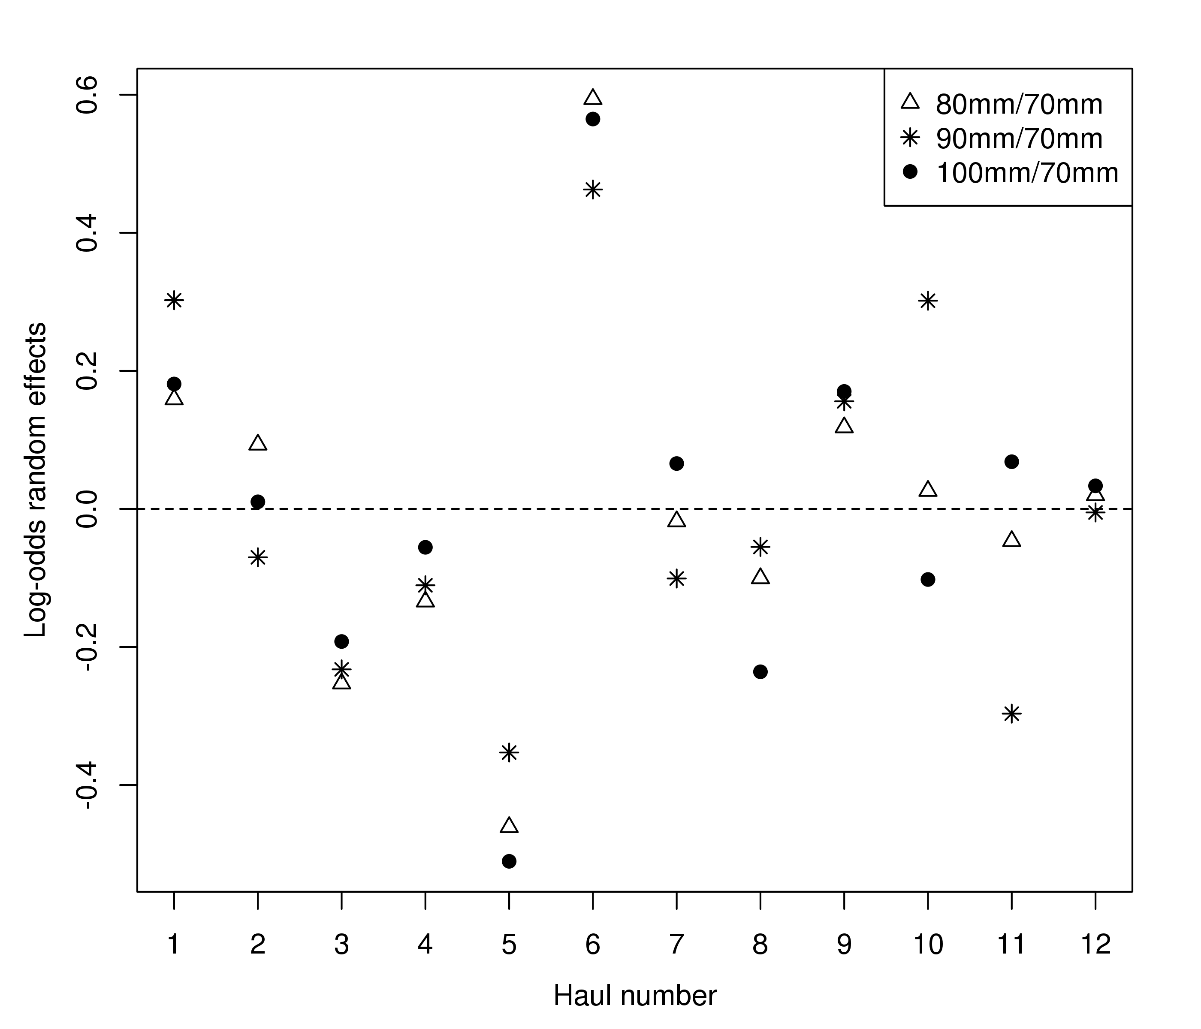

Figure 2. Multi-rig catch comparison. Estimated trivariate random effects (log-odds ratios to the baseline 70mm case: in Equation 6) by haul.

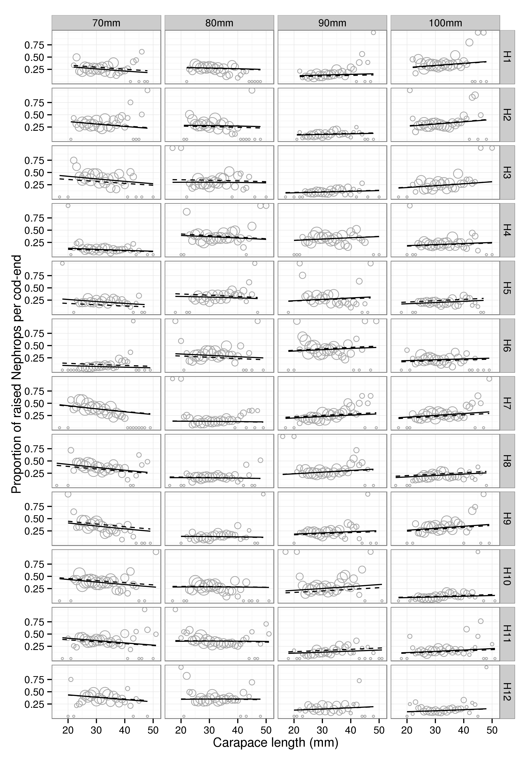

Figure 3. Multi-rig catch comparison. Fitted multinomial mixed effects proportions by haul. Solid and dashed lines represent the predictions from the best fitting model with and without random effects

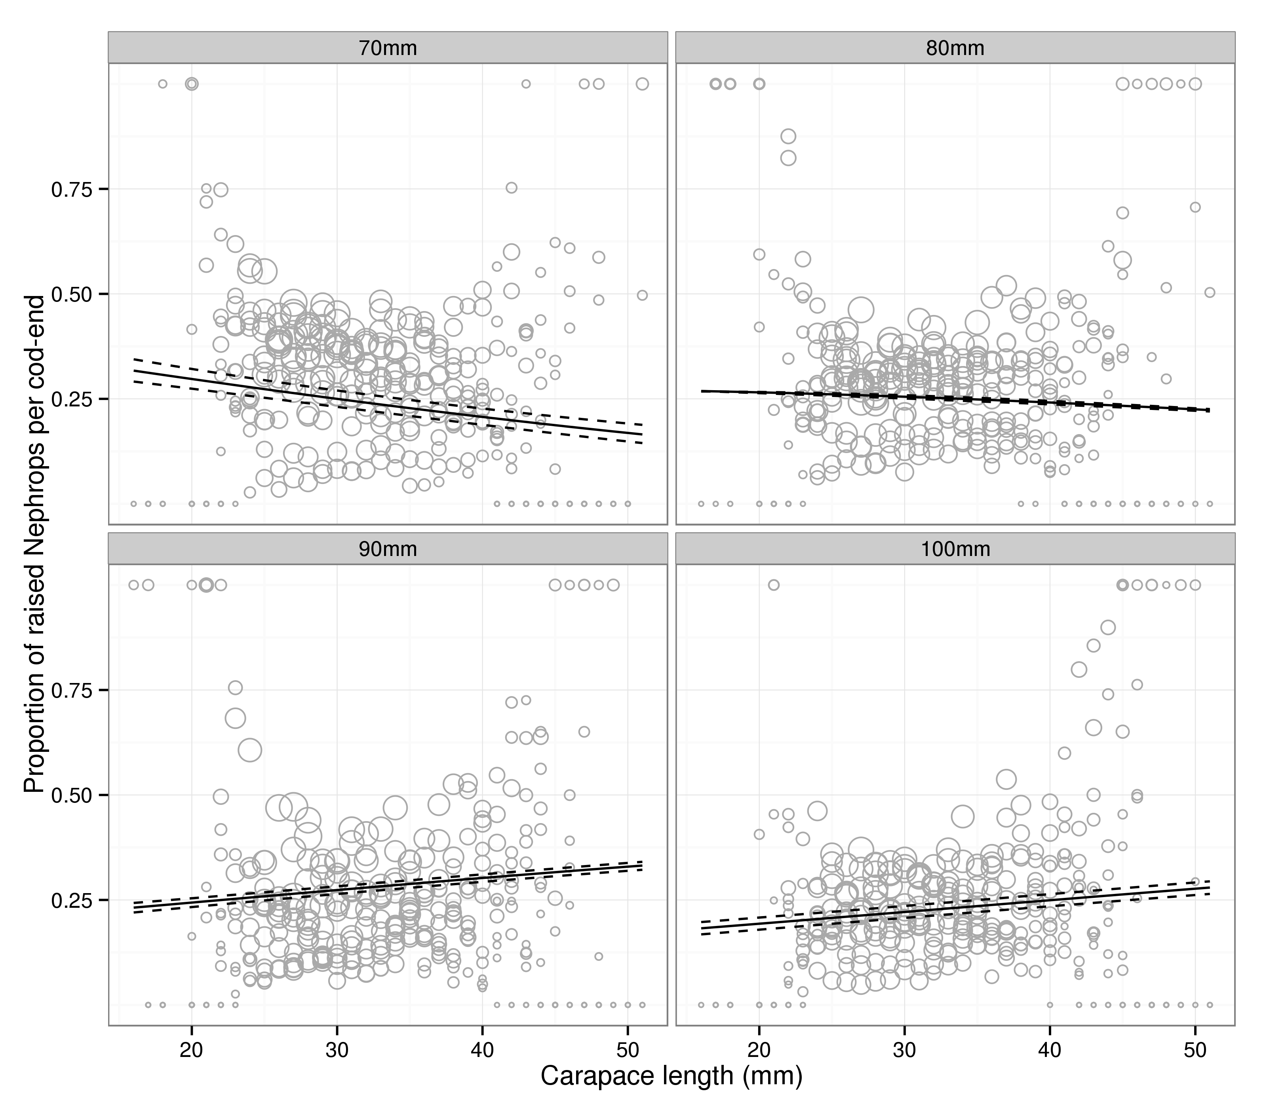

Figure 4. Multi-rig catch comparison. Overall predicted proportions at length. Solid and dashed lines represent the mean and 95% confidence intervals on the mean (see text for discussion on confidence intervals in this setting).